# Top-down manager to direct reports hierarchy using recursion.

* The challenge is to find the top-most level manager and return to the hierarchy of top-level to bottom-level reports-to-to-reportee relationships.
* It should look like the following example
* 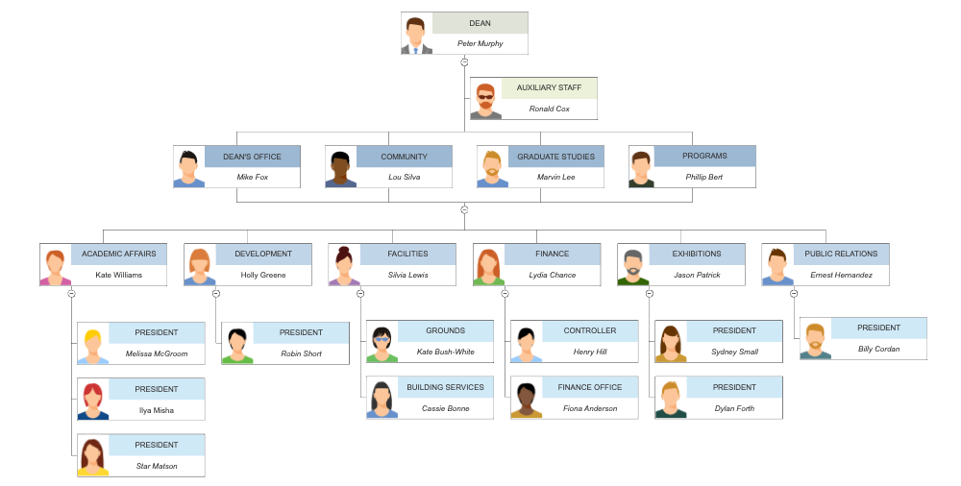
* The JSON Object should look similar to the following example. Additional levels of “direct reports” arrays should be created as needed to ensure the correct structure



## Possible Solution

* I can repurpose the following code to get an array of active users with a manager.



* Using recursion, take the first Syd id in the array and do a gliderecord query to find the manager of the first yester and check if manager 1 has a manager.
  + If manager 1 has a manager, do a new query to determine if manager 2 has one or not. This process should continue until it reaches the nth level manager that does not have one. That manager should then be assigned as the top-level manager in the object array.
* Once the top manager is determined, the recursion script should start over with the second user in the array, but with an additional check.
  + If the current nth level manager reports to the top level manager, the nth level manager should be assigned to as a direct report in the object array.
  + A check also be determined if the current nth-level-manager manager exists within the object array, and if they do, assign them as a direct report.